Christus Lutheran Church

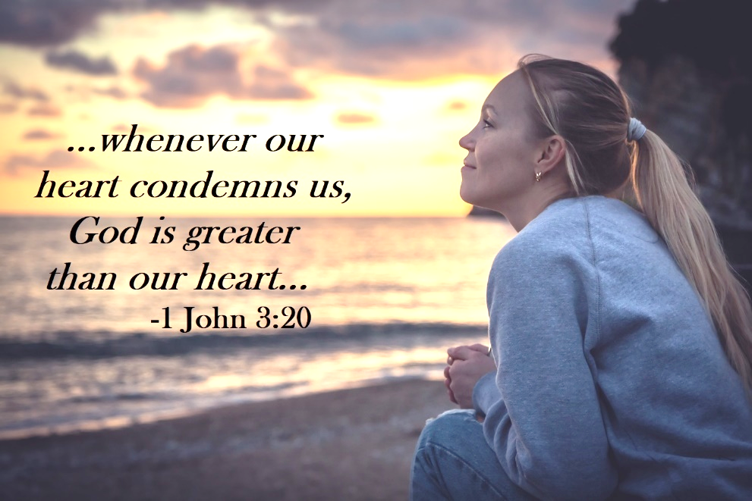

Large Print Complete
April 21, 2024
8am - 10:30am
PRELUDE Nancy Netzel

WELCOME

INVOCATION
P: In the name of the Father, and of the Son, and of the Holy Spirit.
C: Amen

CONFESSION & ABSOLUTION
P: “If we say we have not sinned, we make God a liar, and His word is not in us.” [James 1:10] Let us by all means confess that God and His word are Truth by confessing our sins.
Kneel as you are able, or remain seated
Silence to reflect on the sins that trouble us
P: God of mercy;
C: We cannot deny that we are prone to sin, and are easily overcome by many temptations. In our own strength, we are helpless to resist. For the sake of your beloved Son, forgive us our sins, which are many, that we may love you much. Amen
P: Your heavenly Father hears your heart, and for the sake of the suffering and death of Jesus Christ, forgives you all your sins, and by his resurrection, grants you a new life in Him.
C: Amen! Thank you, Father, for your mercy.

Stand
PEACE
P: “We have peace with God through our Lord Jesus Christ.” [Romans 5:1] May this peace be with you all.
C: And also with you.

Share a sign of peace with those around you

HYMN: Christ is Alive! Let Christians Sing LBW #363

1 Christ is alive! Let Christians sing.
His cross stands empty to the sky.
Let streets and homes with praises ring.
In death his love shall never die.

2 Christ is alive! No longer bound
To distant years in Palestine,
He comes to claim the here and now
And conquer ev’ry place and time.

3 Not throned afar, remotely high,
Untouched, unmoved by human pains,
But daily, in the midst of life,
Our Savior with the Father reigns.

4 In every insult, rift, and war,
Where color, scorn, or wealth divide,
He suffers still, yet loves the more,
And lives, though ever crucified.

5 Christ is alive! Ascended Lord,
He rules the world his Father made,
Till, in the end, his love adored,
Shall be to all on earth displayed.

PRAYER OF THE DAY
P: Let us pray. Merciful heavenly Father;
C: tune our ears and hearts to the voice of the Good Shepherd, your beloved Son, in whom alone we find righteousness and salvation. Grant us faith to follow Him always; through life, through death, and into life everlasting. Amen

Be Seated

FIRST LESSON: Acts 4:1-12
R: The first lesson is from the book of Acts, the 4th chapter
¹ As [the disciples] were speaking to the people, the priests and the captain of the temple and the Sadducees came upon them, ² greatly annoyed because they were teaching the people and proclaiming in Jesus the resurrection from the dead. ³ And they arrested them and put them in custody until the next day, for it was already evening. ⁴ But many of those who had heard the word believed, and the number of the men came to about five thousand.
⁵ On the next day their rulers and elders and scribes gathered together in Jerusalem, ⁶ with Annas the high priest and Caiaphas and John and Alexander, and all who were of the high-priestly family. ⁷ And when they had set them in the midst, they inquired, “By what power or by what name did you do this?” ⁸ Then Peter, filled with the Holy Spirit, said to them, “Rulers of the people and elders, ⁹ if we are being examined today concerning a good deed done to a crippled man, by what means this man has been healed, ¹⁰ let it be known to all of you and to all the people of Israel that by the name of Jesus Christ of Nazareth, whom you crucified, whom God raised from the dead—by him this man is standing before you well. ¹¹ This Jesus is the stone that was rejected by you, the builders, which has become the cornerstone. ¹² And there is salvation in no one else, for there is no other name under heaven given among men by which we must be saved.”
R: The Word of the Lord
C: Thanks be to God

PSALM 23
P: The Lord is my shepherd;
C: I shall not want.
P: He makes me lie down in green pastures.
C: He leads me beside still waters.
P: He restores my soul.
C: He leads me in paths of righteousness
for his name's sake.
P: Even though I walk through the valley of the shadow of death, I will fear no evil,
C: for you are with me; your rod and your staff,
they comfort me.
P: You prepare a table before me
in the presence of my enemies;
C: you anoint my head with oil; my cup overflows.
P: Surely goodness and mercy shall follow me
all the days of my life,
C: and I shall dwell in the house of the Lord forever.

SECOND LESSON: 1 John 3:16-24
R: The second lesson is from 1 John, the 3rd chapter
¹⁶ By this we know love, that he laid down his life for us, and we ought to lay down our lives for the brothers. ¹⁷ But if anyone has the world's goods and sees his brother in need, yet closes his heart against him, how does God's love abide in him? ¹⁸ Little children, let us not love in word or talk but in deed and in truth.
¹⁹ By this we shall know that we are of the truth and reassure our heart before him; ²⁰ for whenever our heart condemns us, God is greater than our heart, and he knows everything. ²¹ Beloved, if our heart does not condemn us, we have confidence before God; ²² and whatever we ask we receive from him, because we keep his commandments and do what pleases him. ²³ And this is his commandment, that we believe in the name of his Son Jesus Christ and love one another, just as he has commanded us. ²⁴ Whoever keeps his commandments abides in God, and God in him. And by this we know that he abides in us, by the Spirit whom he has given us.
R: The Word of the Lord
C: Thanks be to God

CHILDREN’S MESSAGE

Stand
GOSPEL LESSON: John 10:11-18
P: The Holy Gospel, according to St. John, the 10th chapter C: Glory to you, O Lord
[Jesus said:] ¹¹ I am the good shepherd. The good shepherd lays down his life for the sheep. ¹² He who is a hired hand and not a shepherd, who does not own the sheep, sees the wolf coming and leaves the sheep and flees, and the wolf snatches them and scatters them. ¹³ He flees because he is a hired hand and cares nothing for the sheep. ¹⁴ I am the good shepherd. I know my own and my own know me, ¹⁵ just as the Father knows me and I know the Father; and I lay down my life for the sheep. ¹⁶ And I have other sheep that are not of this fold. I must bring them also, and they will listen to my voice. So there will be one flock, one shepherd. ¹⁷ For this reason the Father loves me, because I lay down my life that I may take it up again. ¹⁸ No one takes it from me, but I lay it down of my own accord. I have authority to lay it down, and I have authority to take it up again. This charge I have received from my Father.”
P: The Gospel of our Lord
C: Praise to you, O Christ

Be Seated
SERMON

Stand
HYMN: Savior, Like a Shepherd Lead Us
old red hymnal #524
1 Saviour, like a shepherd lead us,
Much we need thy tender care;
In thy pleasant pastures feed us,
For our use thy folds prepare:
Blessed Jesus, Blessed Jesus,
Thou hast bought us: thine we are.
Blessed Jesus, Blessed Jesus,
Thou hast bought us: thine we are.

2 We are thine; do thou befriend us,
Be the guardian of our way;
Keep thy flock, from sin defend us,
Seek us when we go astray:
Blessed Jesus, Blessed Jesus,
Hear us children when we pray.
Blessed Jesus, Blessed Jesus,
Hear us children when we pray.

3 Thou hast promised to receive us,
Poor and sinful though we be;
Thou hast mercy to relieve us,
Grace to cleanse and power to free:
Blessed Jesus, Blessed Jesus,
early let us turn to thee.
Blessed Jesus, Blessed Jesus,
early let us turn to thee.

4 Early let us seek thy favor,
Early let us do thy will;
Blessed Lord and only Saviour,
With thy love our bosoms fill:
Blessed Jesus, Blessed Jesus,
Thou hast loved us, love us still.
Blessed Jesus, Blessed Jesus,
Thou hast loved us, love us still.

NICENE CREED
P: Together with the saints of all times and places, we confess the one, true faith, using the words of the Nicene Creed: C: We believe in one God, the Father, the Almighty, maker of heaven and earth; of all that is, seen and unseen.
We believe in one Lord, Jesus Christ, the only Son of God, eternally begotten of the Father; God from God, Light from Light, True God from True God; begotten, not made; of one Being with the Father. Through him all things were made. For us and for our salvation, he came down from heaven; by the power of the Holy Spirit, he became incarnate from the virgin Mary, and was made man. For our sake, he was crucified under Pontius Pilate; he suffered death and was buried. On the third day he rose again, in accordance with the Scriptures; he ascended into heaven, and is seated at the right hand of the Father. He will come again in glory to judge the living and the dead, and his kingdom will have no end.
We believe in the Holy Spirit; the Lord, the giver of life, who proceeds from the Father and the Son. With the Father and the Son he is worshiped and glorified. He has spoken through the prophets. We believe in one, holy, catholic and apostolic Church.
We acknowledge one baptism for the forgiveness of sins. We look for the resurrection of the dead, and the life of the world to come. Amen

Be Seated
PRAYERS OF THE CHURCH

OFFERING

Stand
OFFERTORY PRAYER
P: Heavenly Father;
C: We give thee but thine own; whatever the gift may be. All that we have is thine alone; a trust, O Lord, from thee. Amen

THE LORD’S SUPPER

GREAT THANKSGIVING LBW p.88-89
P: The Lord be with you
C: And also with you
P: Lift up your hearts
C: We lift them to the Lord.
P: Let us give thanks to the Lord our God.
C: It is right to give him thanks and praise.
P: It is indeed right… …join their unending hymn:
C: Holy, holy, holy Lord, Lord God of pow’r and
might; heaven and earth are full of your glory.
Hosanna in the highest. Blessed is he who comes in
the name of the Lord. Hosanna in the highest.

WORDS OF INSTITUTION

LORD’S PRAYER

Be Seated

AGNUS DEI LBW p.92
C: Lamb of God, you take away the sin of the
world, have mercy on us. Lamb of God, you take
away the sin of the world, have mercy on us. Lamb
of God, you take away the sin of the world; grant us
peace, grant us peace.

DISTRIBUTION

Stand
POST-COMMUNION BLESSING

ANNOUNCEMENTS

BENEDICTION
P: The Lord bless you and keep you; the Lord make his face to shine on you and be gracious to you; the Lord lift
his countenance upon you and give you peace; in the
name of the Father, and the Son and the Holy Spirit.
C: Amen

HYMN: I Know that My Redeemer Lives! LBW #352
v.1,4,5,7,8
1 I know that my Redeemer lives!
What comfort this sweet sentence gives!
He lives, he lives, who once was dead;
He lives, my ever-living head!

4 He lives to silence all my fears;
He lives to wipe away my tears;
He lives to calm my troubled heart;
He lives all blessings to impart.

5 He lives to bless me with his love;
He lives to plead for me above;
He lives my hungry soul to feed;
He lives to help in time of need.

7 He lives and grants me daily breath;
He lives, and I shall conquer death;
He lives my mansion to prepare;
He lives to bring me safely there.

8 He lives, all glory to his name!
He lives, my Savior, still the same;
What joy this blest assurance gives;
I know that my Redeemer lives!

DISMISSAL
P: We go in peace, to fear God, love God, and trust God.
C: He is to be feared and loved, and He can be trusted. Amen

POSTLUDE Nancy Netzel

Our mission is to invite people of all nations
into fellowship with Jesus Christ,
and to make them His disciples
through preaching and teaching Christ crucified, risen
and coming again as the only hope of eternal salvation.

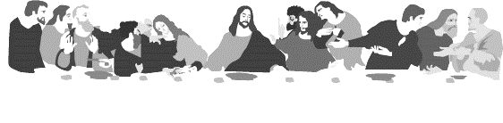
HOLY COMMUNION
All the baptized who believe in the true presence of Christ
in these elements, the bread and wine,
and who know their need of forgiveness,
are welcome to receive the Lord’s Supper.
(1 Cor. 11:23-25; Matt.26:26-28; Mark 14:22-24; Luke 22:19, 20)

Both wine (red) and grape juice (white) are available.
Gluten-free wafers are available – please ask your server for the gluten free wafer if you so choose.
Children who have not received instruction, and those who do not believe in the true presence of Christ in the Supper, may come forward with arms crossed over their hearts to receive a blessing.

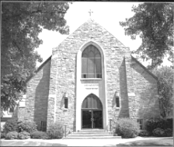
Christus Lutheran Church
120 N. Main St. Clintonville, WI 54929
(715) 823-6521 ● christus@charter.net ●
www.christusclintonville.org
Pastors: Brian Crocker & Shelly Klemp

